Smartboard likes ONLY .mp3 sound files. A good, hassle-free place to go for .mp3 files is Soundzabound. You can get there easily through Pioneer Online Library.
The music comes in different lengths. The sounds to which Smartboard links can be no more than 1:00 minute long.
If you are looking for an animal sound, speeding car, or door closing type sound category, you won’t find those at Soundzabound. Soundabound is music only.
Other .mp3s are available but often the site is blocked at school, or they want you to download some software in order to get the sound.
When you find the .mp3 that you want there are several ways to save it. It depends on the site.
Soundzabound – Very easy –
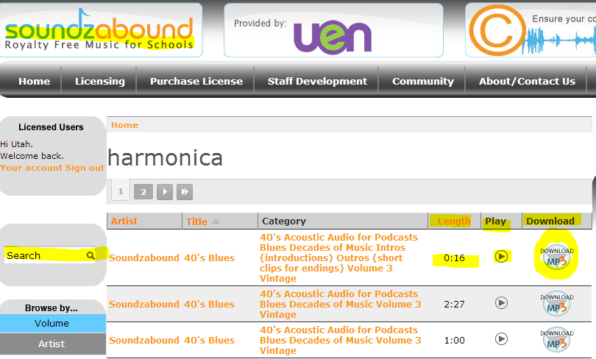
- Search for the type of music you want.
- Push the PLAY arrow on the right.
- Check the Length of the piece.
- Click on Download when you’ve found a suitable piece.
- Make note of where you save it! Desktop, in your Documents, on a jump drive? Make note of where you put it. If you plan to transport it, you want the sound to come with the .notebook file.
- Go back to your .notebook file.
- Select the object or text that you want to link.
- Right click or click the down arrow.
- 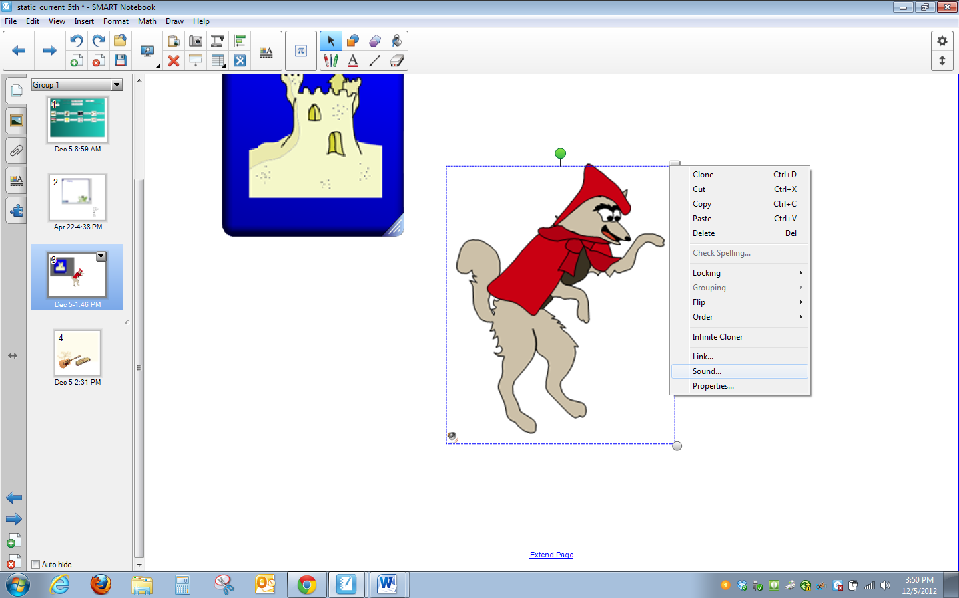
Select sound near the bottom of the menu.
- You will get a new pop up menu.
- Browse to wherever you saved you .mp3
- You will get a new pop up window.
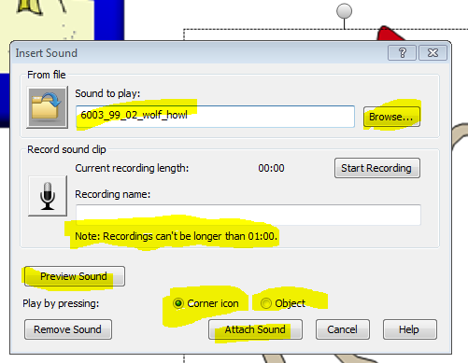

Notice you can also record your own spelling words or other sound here.

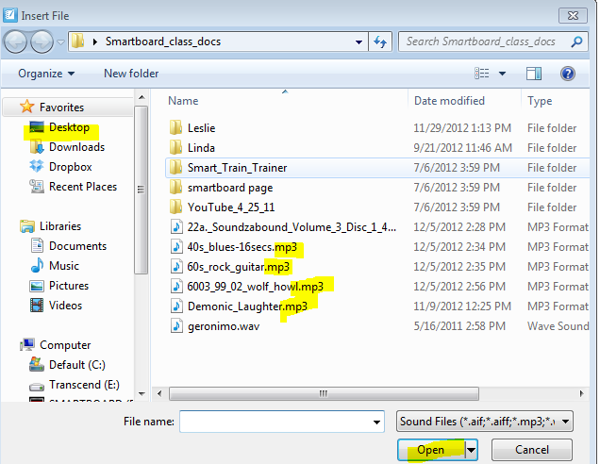
- Choose your .mp3.
- Click Open
- 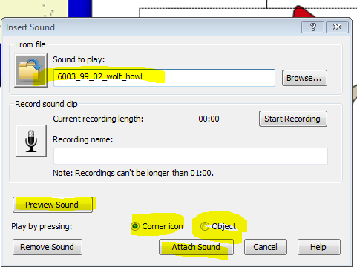
- The name of the .mp3 file shows in the field now.
- Select corner icon or Object.
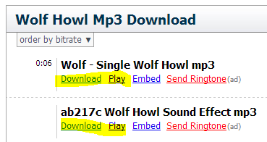
- Attach Sound.
- For the sound of a howling wolf, I googled “wolf howl mp3”. It brought up this link to mp3skull. I am NOT RECOMMENDING this site. I clicked on play to decide which wolf howl I preferred. If you click on download at school, you may get this screen. The link is blocked but as a teacher you should be able to override the block for 15 minutes. Just use your district ID and your normal password.

- Right click on the recording bar.
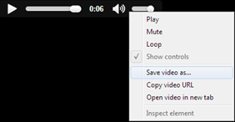
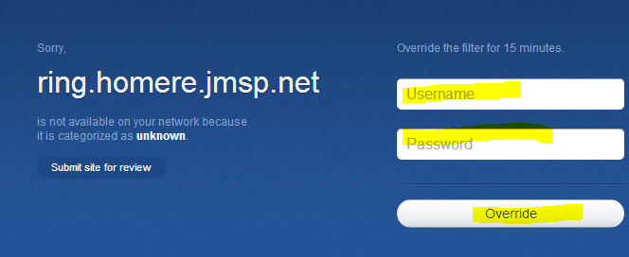
- Chose Save Video File As or Save As. The terminology will depend on the site. Just try whatever makes the most sense. It’s one of THOSE questions.
- Then you will get this new window. Select the place where you want the .mp3 to live on your computer, jump drive, shared drive, or wherever. Remember where you put it. You can also rename it. I would just keep the words “wolf_howl” and delete the numbers .
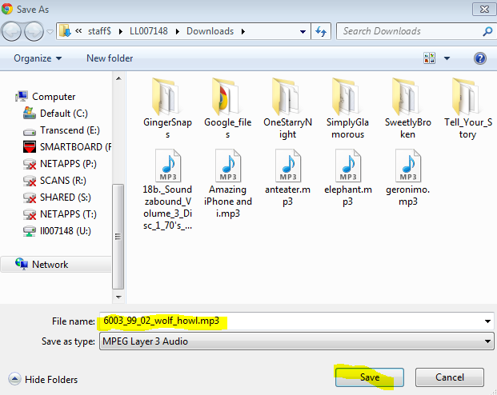

- Follow the same procedure as above to link the file to your object or text.

