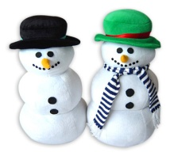
Key to Interpreting Snowman Glyphs
Glyph symbol | Key
Arms stretched out straight | Likes winter
Arms bent | Does not like winter
4 fingers on ends of arms | Toes get the most cold in winter
3 fingers on ends of arms | Fingers get the most cold in winter
3 buttons | Likes to play in the snow
4 buttons | Does not like to play in the snow
Red hat | Likes to go sledding the most
Purple hat | Likes to go skiing or snowboarding the most
Blue hat | Likes to go ice skating the most
Green hat | Likes to build awesome snowmen the most
Orange scarf | Prefers hot chocolate in the winter
Yellow scarf | Prefers hot apple cider in the winter
Green scarf | Prefers chili in the winter
Blue scarf | Prefers soup in the winter
Red mouth | Likes to watch a movie on cold days
Pink mouth | Likes to read a book on cold days
Black mouth | Likes to play in the snow on cold days

