- Select Gallery
  - Type in balloons
  - Choose Interactive and Multimedia.
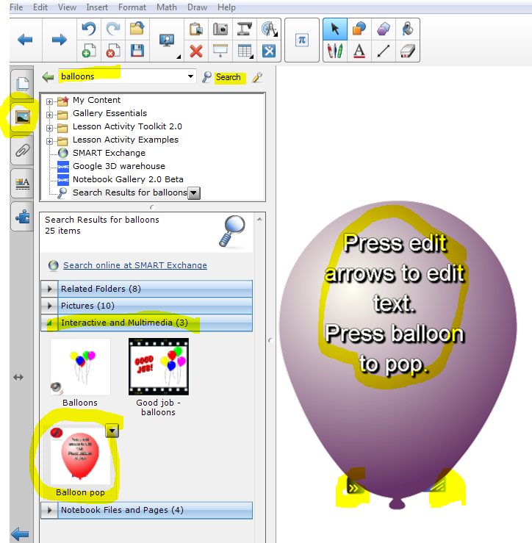
  - Drag the single balloon over to your work area.
  - This activity involves layers. The outside layer of the balloon is edited by clicking on the tab with the two arrows on the lower left of the balloon. When you click on that, the color of the balloon changes to sort of a mimeograph color.
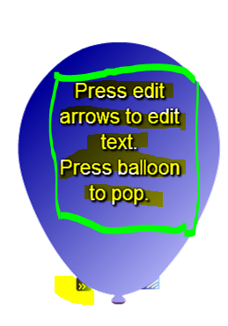
  - As you highlight the words – Press edit arrows…… a green box will appear around the words and the words will be highlighted in black. Type the answer or the question on the balloon in this area.
  - Click on the tab with the arrows again. Now you will be able to pop the balloon.
  - Decide on the placement of the balloon in your work area. That is the spot where you will put the picture or the words.
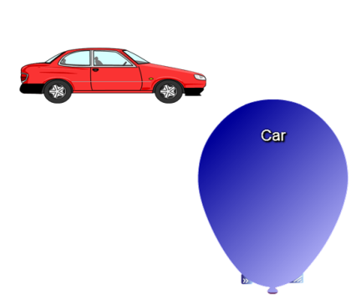
  - You may have to decrease the size of the object or increase the size of the balloon. To change the size of the balloon, pull or push at the tab at bottom right of the balloon. To change the size of the other object, push or pull one of the corners of the objects. There is usually a little circle at each corner. You can rotate some objects as well.
  - If you move the balloon over the car, the car may show up ON TOP of the balloon instead of behind it. Move the balloon out of the way. Right click or down arrow, go to Order, chose Send to Back. *
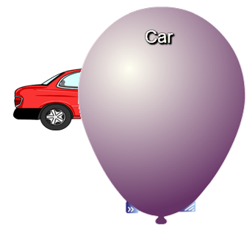
  - Lock the object, in this case the car, in place. Go to the down arrow or right click, go to Locking, Lock in place.
  - You may use text behind the balloon instead of an object. Other objects may be layered this way as well.
* Or you may click on the balloon, choose Order, and Bring to Front.

